Personal information:
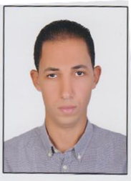
Name:Ali Ahmed Mohamed Mohamed Salem
Egyptian, single, Birth Date: 20/1/1990.

Address: Elmuhandisin _ Cairo- Egypt
Mobile1:002-01009800116Mobile2:002-01093719010
Driving license: Personal – Valid
Not smoker.

Objective:

To get a job opportunity in your remarkable company to enhance my
Knowledge and I hope to add a new value to your company & make
Something special.

Education:

Bachelor of Faculty of Commerce, Alexandria University,

Graduation Year: May 2011Total Grade:Good

Work experience:

Past:

- Sales man for AMAKEN for real state and development
FROM 10/2013To7/2014

- Supervisor for ENJAZ for real state and development
From 7/2014To6/2015
- Supervisor for AMLAK for real state and development
From 7/2015To5/2017
- Supervisor for bnaya for real state and development
From 5/2017 To 2 /2018

Present:

- Sales man for MSG for real state and development
FROM 2/2018 To Untill Now.

Coursesand Training:

- English course.
- ICDL

Computer skills:

- ICDL International Computer Driving License
- Excellent moderator of Microsoft windows (XP& 7).
- Excellent internet skills.

Further skills:

- Ability to work under stress.
- Courageous in decision making, determined person.
- Good presentation skills.
- Good communication skills.
- Good time management skills.
- Get into team mode very quickly.
- Accurate & well organized
Military service:

Soldier at Army Forces
1/2012 to 3/2013

Language skills:

- Arabic: Mother Language.
- English:Good (Writing & Speaking).

